Jubilee 3D Documentation (Part 1)
Prepared by: Arthur Chong
Date: 05/16/2025
This document is the first part of a multi-part guide that provides step-by-step instructions on how to build and connect a Jubilee 3D printer from scratch.

Jubilee 3D Documentation (Part 1) 1
Building Jubilee 1
1. Jubilee Project Wiki 2
2. Purchase Information 2
3. Inventory of Components 2
4. Jubilee Assembly 2
5. Electronics 4
6. Customizable Jubilee 6
Connecting Jubilee 7
1. Installation Prerequisites 8
2. Setting Up an IP Address 8

Building Jubilee

1. Jubilee Project Wiki
The official Jubilee Project Wiki can be found at:
👉 https://jubilee3d.com/index.php?title=Main_Page
This site includes comprehensive information on:
- The overall design and philosophy of Jubilee
- Detailed build instructions
- Maintenance procedures and best practices

2. Purchase Information
The Jubilee motion platform kit used in the UW Sun Lab was purchased from:
🛒 https://www.filastruder.com/collections/jubilee/products/jubilee-motion-platform-kit

3. Inventory of Components
A full list of items included in the kit, as well as additional optional components sourced from other vendors (e.g., Amazon, Filastruder, etc.), can be found on GitHub:
📦 GitHub Items List (Items.md)
👉 https://github.com/uwsunlab/Axolotl_Jubilee/blob/main/Documentation/Building/Items.md

4. Jubilee Assembly
To begin assembling the Jubilee, refer to the official build instructions linked below. This step-by-step guide walks through the entire construction process, including subassemblies and grouped components:
🛠️ https://jubilee3d.com/index.php?title=Assembly_Instructions
If needed, refer to the image below for guidance on navigating to this page from the main Wiki.
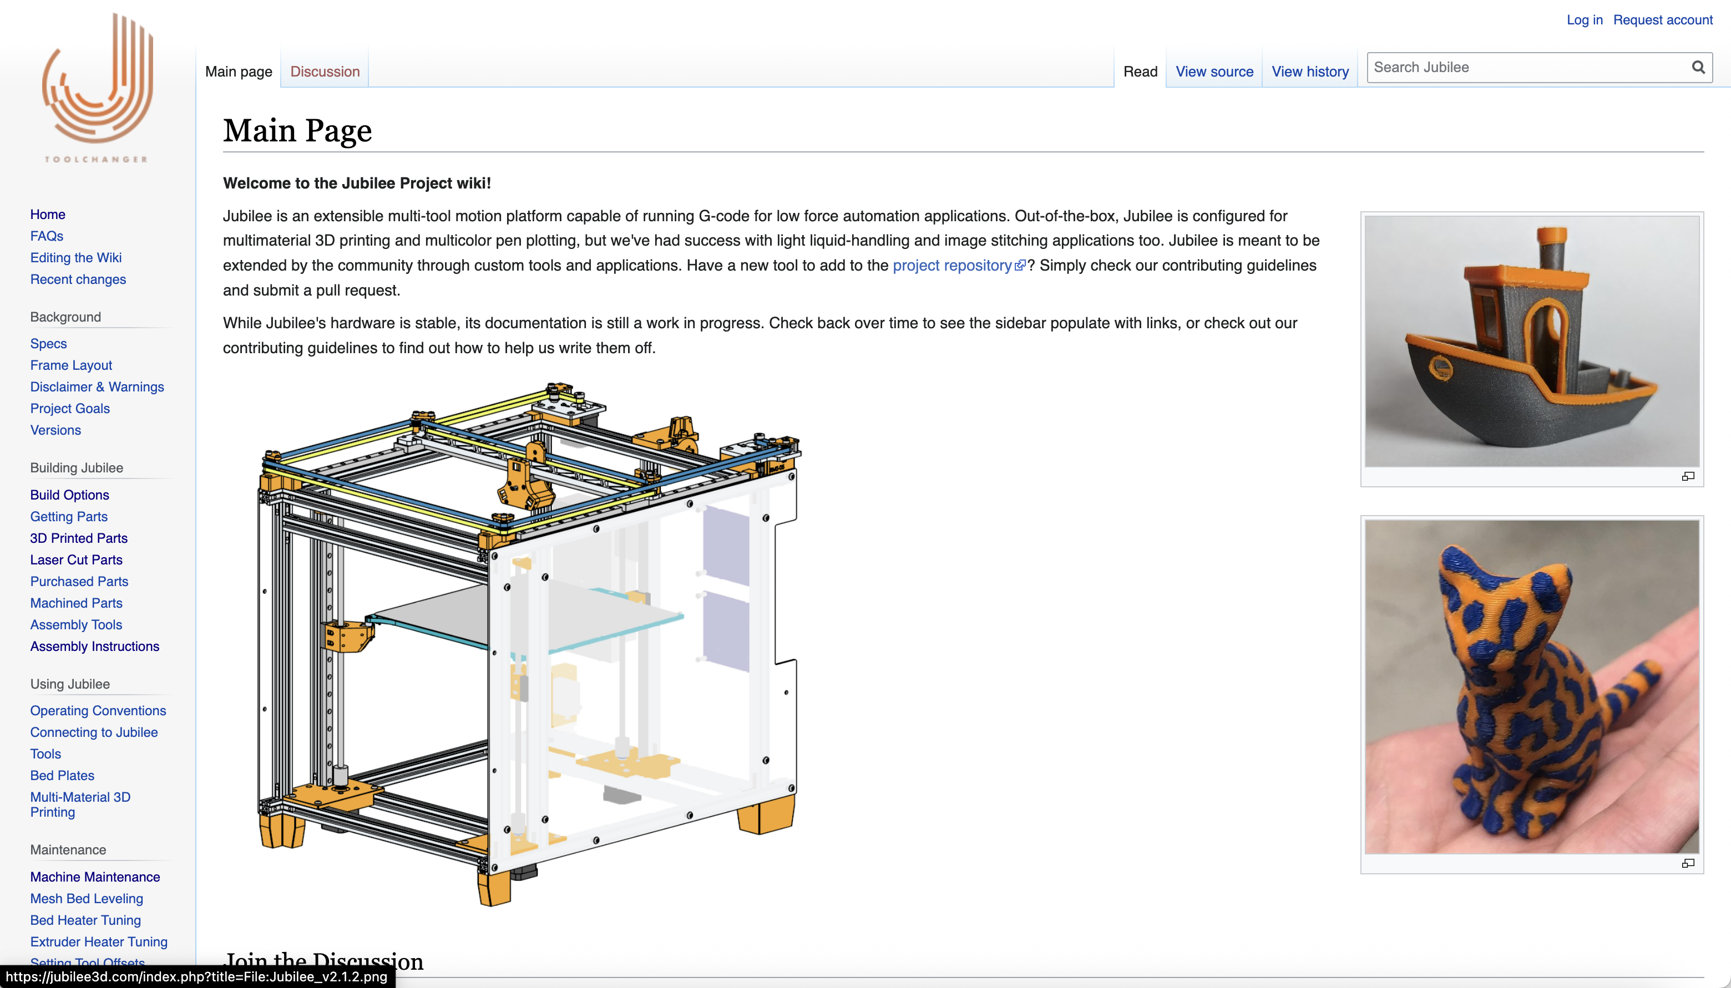

Grouped Assembly Sections
The Jubilee Assembly page is divided into multiple sections, each focusing on a specific part of the machine:

SECTION 1
- Outer Frame Assembly and Alignment
- Aluminum Motor Plate Assembly
- Double Pulley Corner Plate Assembly
- Aluminum Crossbar Assembly
- Toolchanger Remote Elastic Lock Assembly
- Toolchanger Carriage Assembly
- Magnetic Build Plate Assembly
- Duet2 Electronics Panel Assembly

SECTION 2
- Lower Frame Assembly
- CoreXY Frame Assembly

SECTION 3
- Z Axis Assembly

Additional Build Notes
We have also compiled additional notes that may help streamline the building process. These include clarifications, tips, and lessons learned from our build experience:
📝 Notes for Building Jubilee (PDF)

5. Electronics
In the official Jubilee Assembly Instructions, there is a dedicated section on electronics. This section explains how to properly connect the wiring behind the Jubilee before powering on the machine.
⚠️ Important: The wiring instructions depend on the type of control boards you are using. Please follow the specific wiring diagram provided on the website that corresponds to your hardware configuration.

Control Board Used in UW Sun Lab
For the UW Sun Lab setup, we used the following configuration:
- Duet 3 Mini + 3HC Expansion Wiring
The corresponding wiring diagram from the official Jubilee documentation is shown below:
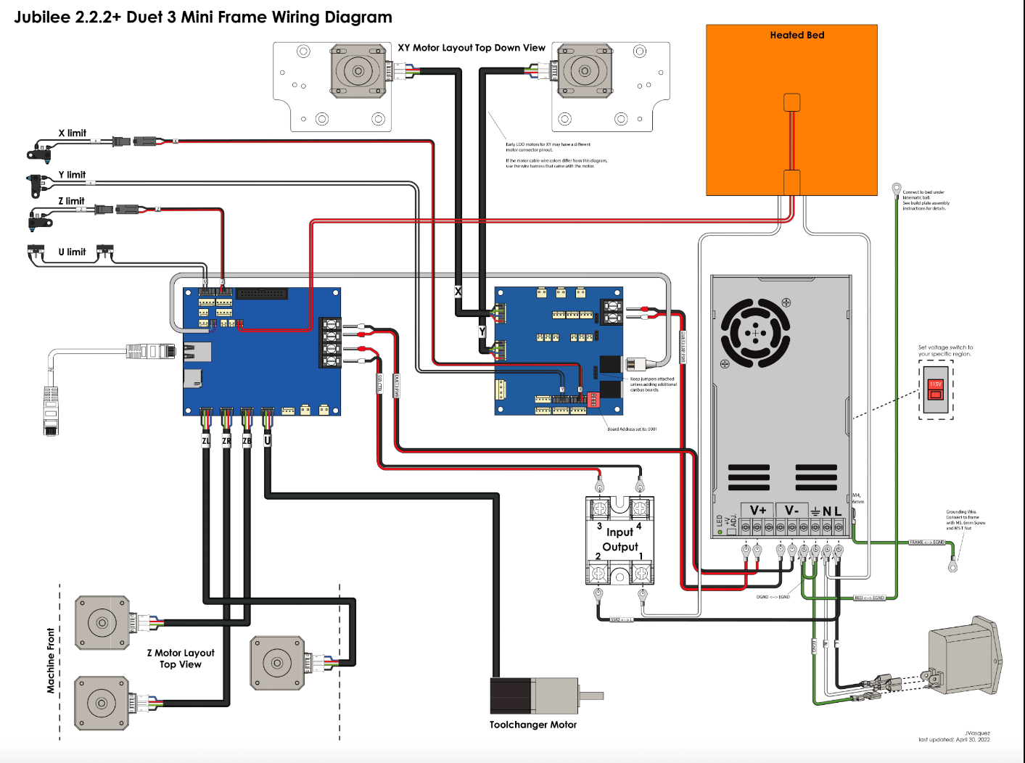

Axolotl (Our Jubilee) Wiring Reference
The figure below shows the custom wiring setup used in the Axolotl system within our lab. This image may help visualize wire routing, board positioning, and component connectivity during the assembly process:
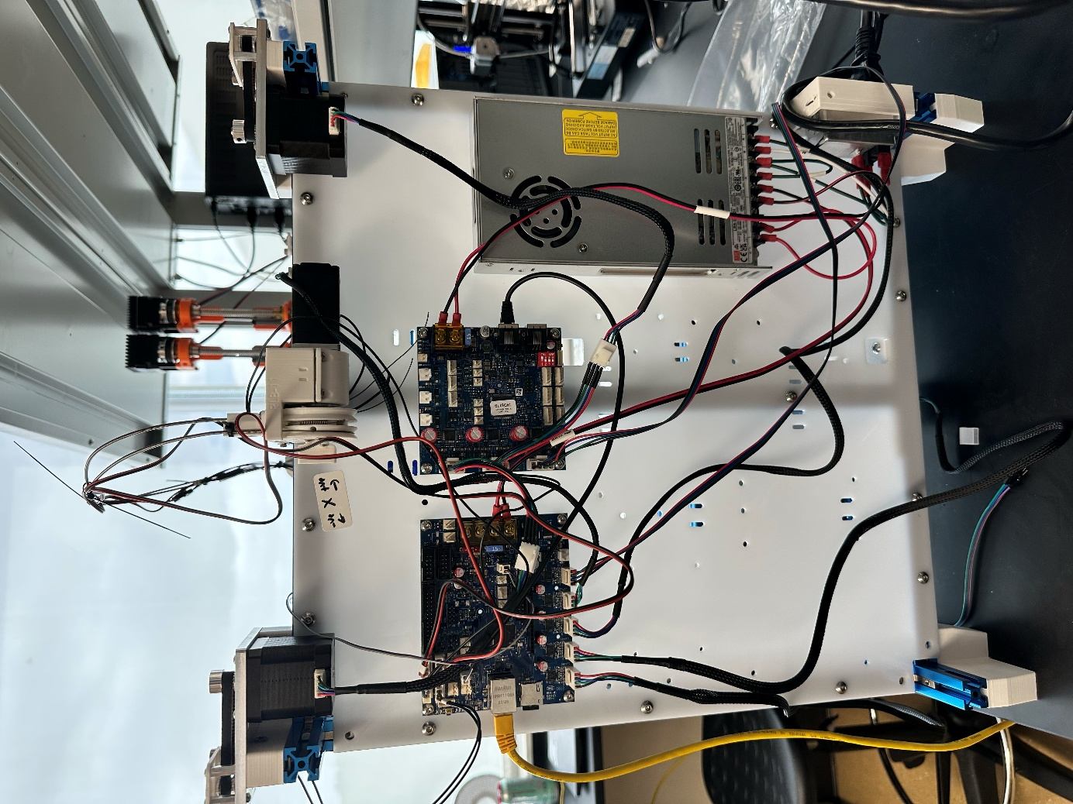

6. Customizable Jubilee
This section outlines the various tools that can be attached to the Jubilee 3D printer frame for experimental or automation purposes.
The Science Jubilee website is a valuable resource that provides information on using Jubilee for lab automation tasks. It includes a dedicated page—Building Science Jubilee Tools—which lists supported tools that are compatible with the Jubilee system.
🔗 Science Jubilee – Building Tools Page

Common Tools Used in Science Jubilee:
- Pipette Tool
- Inoculation Loop Tool
- Camera Tool
- Side Camera Tool
- HTTP Syringe Tool
- Lab Automation Deck
These tools are designed to integrate seamlessly with the Jubilee motion platform for automated laboratory workflows.

Designing Custom Tools
Users can also design and attach custom tools to the Jubilee frame to suit specific experimental needs.
To learn how to design your own tools, refer to the following page:
🛠️ Designing Custom Tools

Tool Pick-Up Requirements
After designing and mounting your custom tool, you must define its exact location so Jubilee can accurately pick it up during operation.
For instructions on setting tool positions and prerequisites, refer to:
📍 Tool Postrequisites

Connecting Jubilee

1. Installation Prerequisites
Before connecting to the Jubilee, ensure that all necessary files and dependencies are installed on your system. Follow the step-by-step installation guide provided by the Science Jubilee documentation:
🔧 Installation Instructions
👉 https://science-jubilee.readthedocs.io/en/latest/getting_started/installation.html

2. Setting Up an IP Address
To initialize communication with Jubilee, you must connect the machine via an Ethernet cable and assign a fixed IP address.
Jubilee provides detailed instructions on how to configure this connection properly. This step is essential to ensure the control board is accessible over your local network.
🌐 Connecting to Jubilee
👉 https://jubilee3d.com/index.php?title=Connecting_to_Jubilee

